1. What structures are included in the basal ganglia? List the main receiving areas and output areas of the basal ganglia.

Receive area: corpus striatum, include caudate and putamen.

Output area: pallidum, include globus pallidus and substantia nigra pars reticulate.

2. Parallel loops involving the basal ganglia each handle information from different cortical areas. Diagram the motor loop, indicating whether each of the pathways is excitatory or inhibitory. What are the other loops?

Other loops: Non-motor loops: Prefrontal loops and Limbic loops.

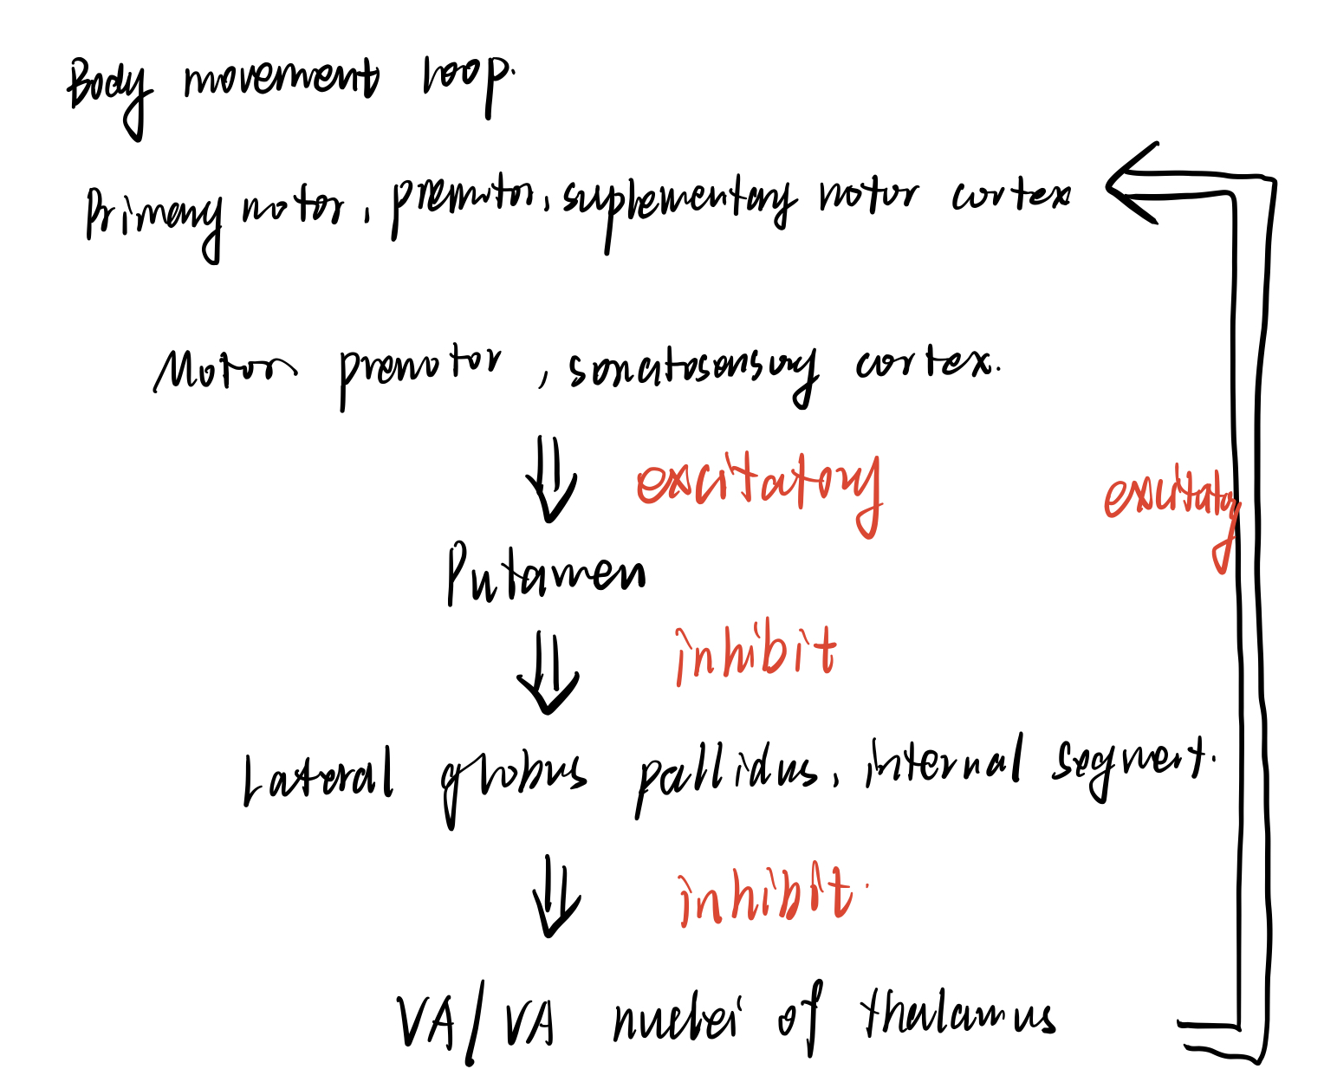 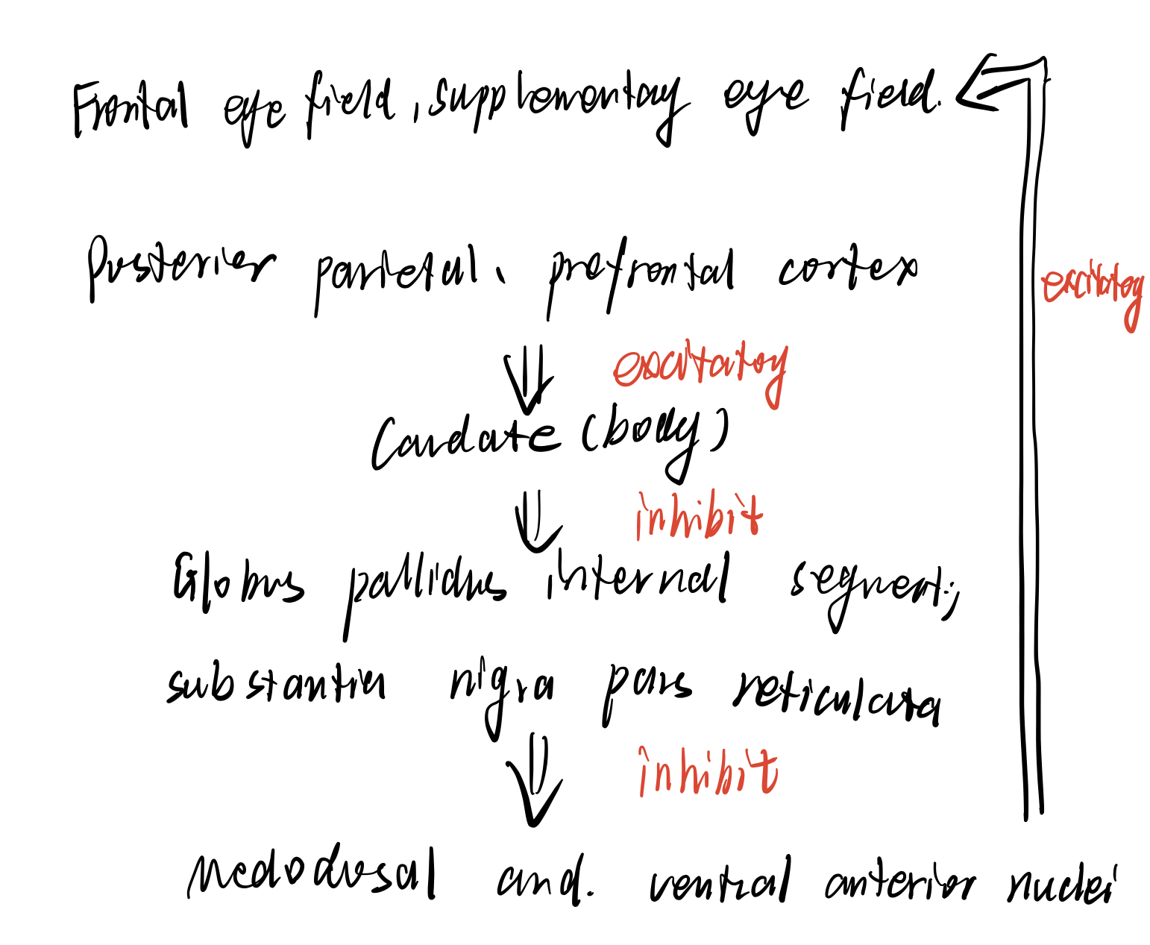

3. What is disinhibition? Briefly describe how inhibition and disinhibition operate in the control of saccades.

Disinhibition: Assume that neuron A can inhibit neuron B and neuron B can inhibit neuron C. When A is resting, B is active and C is inhibited. When A is active, B is inhibited and C is active, and we also say C is disinhibited.

Saccade: The input of caudate neurons inhibits the reticulata neurons and cause the disinhibition of superior colliculus, allowing them to form action potential to command saccades.

4. In Huntington’s disease, which neurons in the basal ganglia are the main ones that degenerate? Explain in terms of basal ganglia circuitry how this would lead to hyperkinetic symptoms.

**Degeneration**: The projection from the caudate and putamen to the external segment of the globus pallidus is diminished.

**Explanation**: The degenerated projection is to inhibit external segment of globus pallidus, and with the damage to this projection, the affection of inhibited projection from external segment will increase. Therefore, the activation of neurons in subthalamus nucleus will be abnormally inhibited and they cannot excite neurons in internal segment of globus pallidus. Ultimately, projection from internal segment to VA/VL complex shows less tonic inhibition and VA/VL complex exited frontal cortex abnormally, leading to often inappropriate motor activity.

5. In Parkinson’s disease, which neurons degenerate? Explain the hypokinetic symptoms of this disease in terms of the circuitry of the basal ganglia. What kinds of treatments have been used to alleviate Parkinson’s symptoms?

**Degeneration**: The dopaminergic inputs provided by the substantia nigra pars compacta are diminished.

**Explanation**: The disorder of dopaminergic inputs makes transient inhibition of internal segment of globus pallidus more difficult to form. The result is that the VA/VL thalamus will less likely to be disinhibited, causing the reducing of appropriate motor behavior.

**Treatments**: Medical: Levodopa; Surgery.

6. What are the functional differences between the cerebrocerebellum, vestibulocerebellum, and spinocerebellum?

**Cerebrocerebellum**: planning movement and evaluating sensory information for action.

**Vestibulocerebellum**: The main function of the vestibulocerebellum is to receive sensory input from the vestibular nuclei in the brainstem and to regulate equilibrium, balance, and the vestibulo-ocular reflex accordingly.

**Spinocerebellum**: carry signals to the brain about the position of your limbs and joints

7. Name the three cerebellar peduncles. Which contain cerebellar afferents and which contain efferents? To or from which area/nuclei?

**Superior peduncle**: Efferent. Mainly project to motor nuclei of dorsal thalamus and upper motor neurons in the deep layers of superior colliculus.

**Middle peduncle**: Afferent. Mainly from pontine nuclei

**Inferior peduncle**:

Afferent: From the vestibular nuclei, the spinal cord, and several regions of the brainstem tegmentum.

Efferent: project to vestibular nuclei and the reticular formation.

8. Diagram the basic circuit of the cerebellum, showing a Purkinje cell, granule cell, parallel fiber, mossy fiber, climbing fiber, and a neuron in a deep cerebellar nucleus. Label the three layers of the cerebellar cortex.

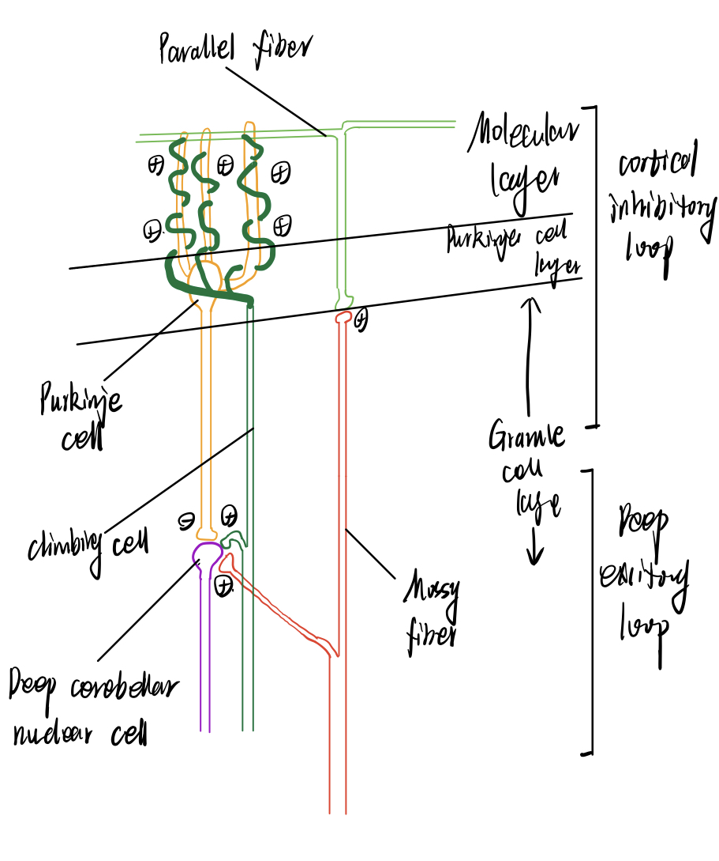

9. What type of neurons carry the output of the cerebellar cortex? Is it true that all of the output of the cerebellar cortex is inhibitory? Do you think this is inconsistent with the complex tasks of the cerebellum?

The Purkinje cells. It is true that all of the output of the cerebellar cortex is inhibitory. I don’t think this is inconsistent with the complex tasks of the cerebellum because neurons in deep cerebellum also receive excitatory input from mossy and climbing fiber.